1. Start Virtual ChemLab (Beyond Labz), select Atomic Theory, and then select Thomson Cathode Ray Tube Experiment from the list of assignments. The lab will open in the Quantum laboratory.
2. What source is used in this experiment? Drag your cursor over to the source to identify it. (1 pt)
Alpha source
What type of charge do electrons have? (1 pt)
Electrons are negatively charged
What detector is used in this experiment? (1 pt)
Laser detector
3. Turn on the Phosphor Screen by clicking on the red/green light switch.
What do you observe? (1 pt)
Electron spot is detected at the center of the phosphor screen
The phosphor screen detects charged particles (such as electrons) and it glows momentarily at the positions where the particles impact the screen.
4. It may be helpful to drag the lab window down and left and the phosphor screen window up and right in order to minimize overlap. Push the Grid button on the phosphor screen, and set the Magnetic Field to 30 μT. (Click buttons above and below the digits in the meter to raise and lower the value. Clicking between digits moves the decimal point.)
What happens to the spot from the electron gun on the phosphor screen? (1 pt)
The spot from the electron gun moves to 3.5 cm towards the right of the phosphor screen
Trial 1: Set the Magnetic Field back to zero and set the Electric Field to 10 V.
Trial 2: Choose your own value
What happens to the spot on the phosphor screen? (2 pt) For both trials.
Trial 1: the spot on the phosphor screen is deflected to the left, about 3.9 cm from the center of the screen.
Trial 2: When the electric field is set to 4 V and the magnetic field to zero, the spot on the phosphor screen is deflected to the left, about 1.5 cm from the center of the screen.
Where should the signal on the phosphor screen be if the electric and magnetic forces are balanced? Write the values for both fields. (3 pts) For both trials.
Trial 1: 2.6 cm
Trial 2: 5.4 cm

6.
Trial 1: Increase the voltage of the Electric Field so the spot is 5 cm left of center.
Trial 2: Choose your own distance.
What voltage is required? (3 pts)
Trial 1: 13.0 V
Trial 2: 8.00 V
7. Increase the magnetic field strength until the spot reaches the center of the screen. Do this for both trials.
What magnetic field creates a magnetic force that balances the electric force? (3 pts)
Trial 1: 44.0 μT
Trial 2: 27.0 μT

[insert a screen shot for Trial 1] (2 pts)
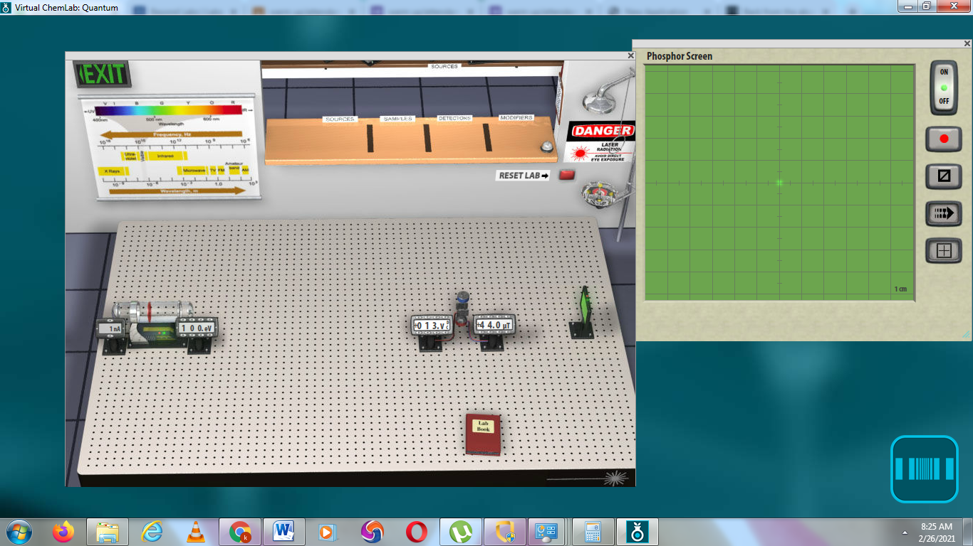

[insert screen shot for trial 2] (4 pts)
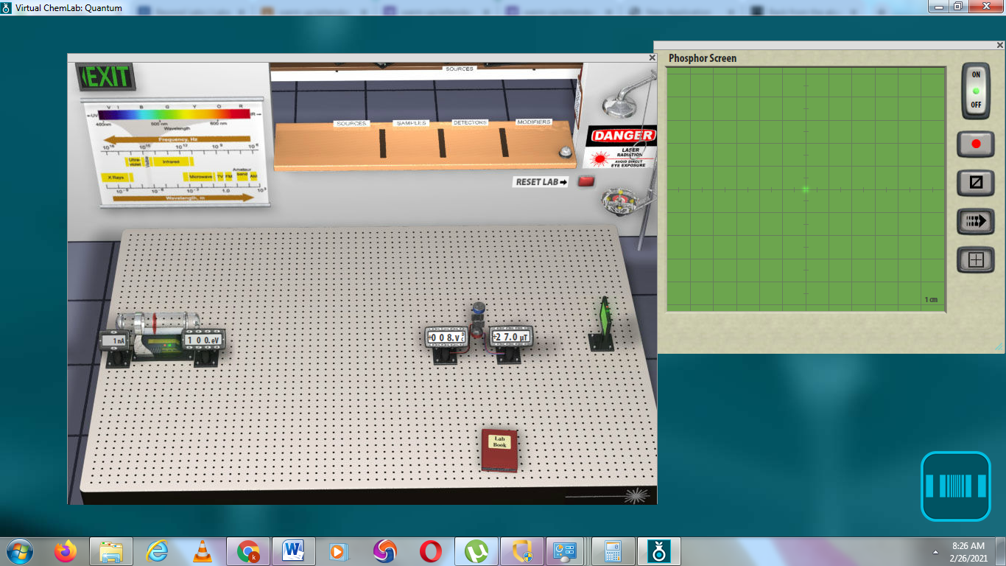

DATA TABLE ( 3 pts)
 | Deflected distance (cm) | Electric field in volts | Magnetic field (B) in μT
Trial 1 | 5.00 | 13.0 | 44.0
Trial 2 | 1.50 | 8.00 | 27.0

Calculations: (you must show ALL the calculations for both trials including the % error) (4 points each)
In a simplified and reduced form, the charge-to-mass ratio (q/m_{e}) can be calculated as follows:
$\frac{q}{m_{e}}$ = $\frac{5.0826 x {10}^{12}(V)(d)}{B^{2}}$
Trial 1
$\frac{q}{m_{e}}$ = $\frac{5.0826 x {10}^{12}(13.0)(5.00)}{{44.0}^{2}}=1.7065x {10}^{11}$

Trial 2
$\frac{q}{m_{e}}$ = $\frac{5.0826 x {10}^{12}(8.00)(1.50)}{{27.0}^{2}}=8.3664 x {10}^{10}$

Error: $\frac{True value-Experimental value}{True value}$ x 100
True Value: for q/m_{e} = 1.76 x 10¹¹
Trial 1
Error: = $\frac{True value-Experimental value}{True value}$ x 100 = $\frac{1.76x {10}^{11}-1.7065x {10}^{11}}{1.76x {10}^{11}}$ x 100 = Error = 3.04%

Trial 2
Error: = $\frac{True value-Experimental value}{True value}$ x 100 = $\frac{1.76x {10}^{11}-8.3664 x {10}^{10}}{1.76x {10}^{11}}$ x 100 = Error = 52.5%

(No points will be taken off if the results are below 5%. 6%-10% two points will be taken off and above 10% 3 points will be taken off).
Error: $\frac{True value-Experimental value}{True value}$ x 100
True Value: for q/m_{e} = 1.76 x 10¹¹
Trial 1
Error: = $\frac{True value-Experimental value}{True value}$ x 100 = $\frac{1.76x {10}^{11}-1.7065x {10}^{11}}{1.76x {10}^{11}}$ x 100 = Error = 3.04%

Trial 2
Error: = $\frac{True value-Experimental value}{True value}$ x 100 = $\frac{1.76x {10}^{11}-8.3664 x {10}^{10}}{1.76x {10}^{11}}$ x 100 = Error = 52.5%

Discussion: (Explain why errors occurred, if you can explain why then the penalty points for % error will get reduced). (2 pts).
The error especially in trial 2 occurred due to inaccuracy in obtaining exact reading of the electron distance from the grid on the phosphor screen. The values obtained are approximations hence increase uncertainty.

